**Santa Treasure Website Documentation**

**Overview**

Santa Treasure is an website that offers a range of Christmas-themed products, with a focus on festive treasures, gifts, and decorations. It provides a user-friendly interface for both customers and admins to browse, manage, and purchase items.

This website is built using modern web technologies such as Django for the backend, HTML, CSS, JavaScript for the frontend, and a MySQL database for data storage.

**1. User Features:**

* **User Registration and Authentication:** Users can create an account, log in, and manage their profile.
* **Product Catalog:** A comprehensive list of available products with categories and detailed descriptions.
* **Search Functionality**: Users can search products by name, category, or price.
* **Product Details:** View detailed information about products, including images, prices, and specifications.
* **Shopping Cart:** Add items to the cart, adjust quantities, and remove items.
* **Secure Checkout:** Users can place orders securely with Razorpay payment integration

**2. Admin Features:**

* **Admin Dashboard**: Manage all aspects of the website from a single interface.
* **Product Management**: Add, edit, or delete products from the catalog.
* **Order Management**: View, update, and manage customer orders.
* **Order Tracking**: Track status of the order by using Order id.
* **Route Optimization**: Optimizing the delivery route for timely and efficient order deliveries.
* **OTP for Safe Delivery**: Admins can generate and send an OTP for secure delivery, ensuring that the recipient receives the correct order.

**Santa’s Treasure Home Page for User**

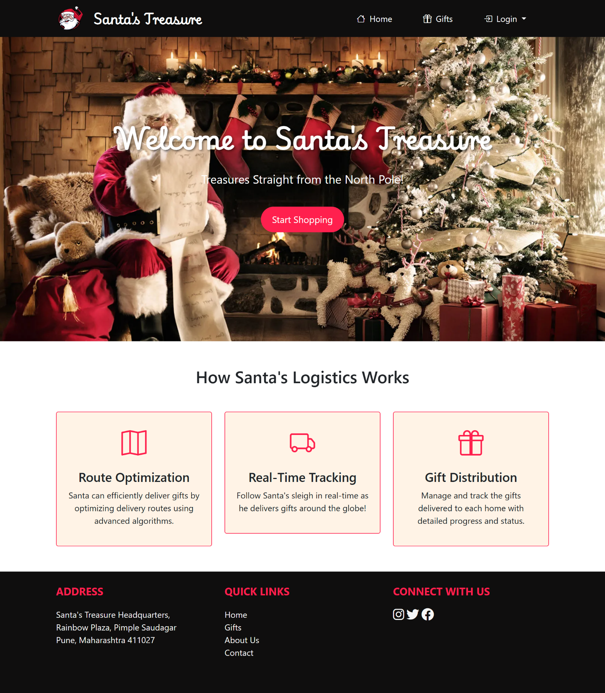

**Register Page for User**

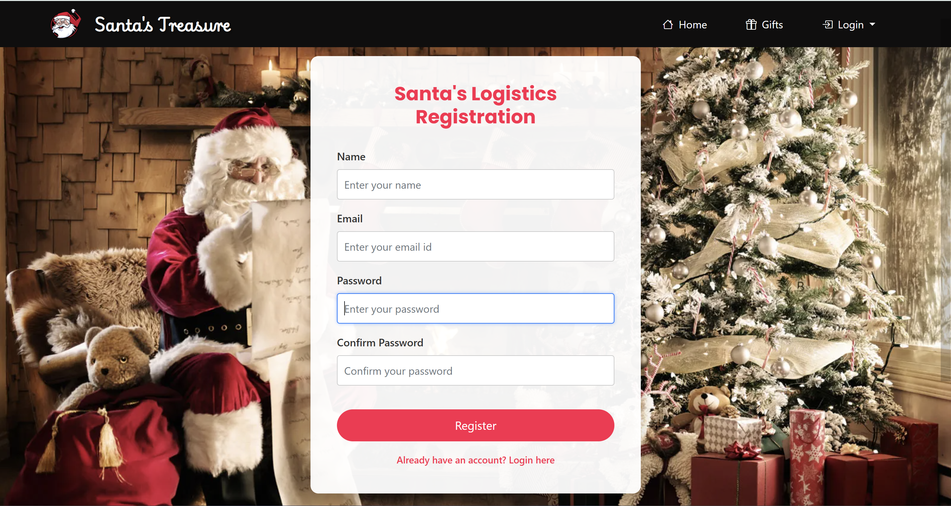

**Login Page for User**

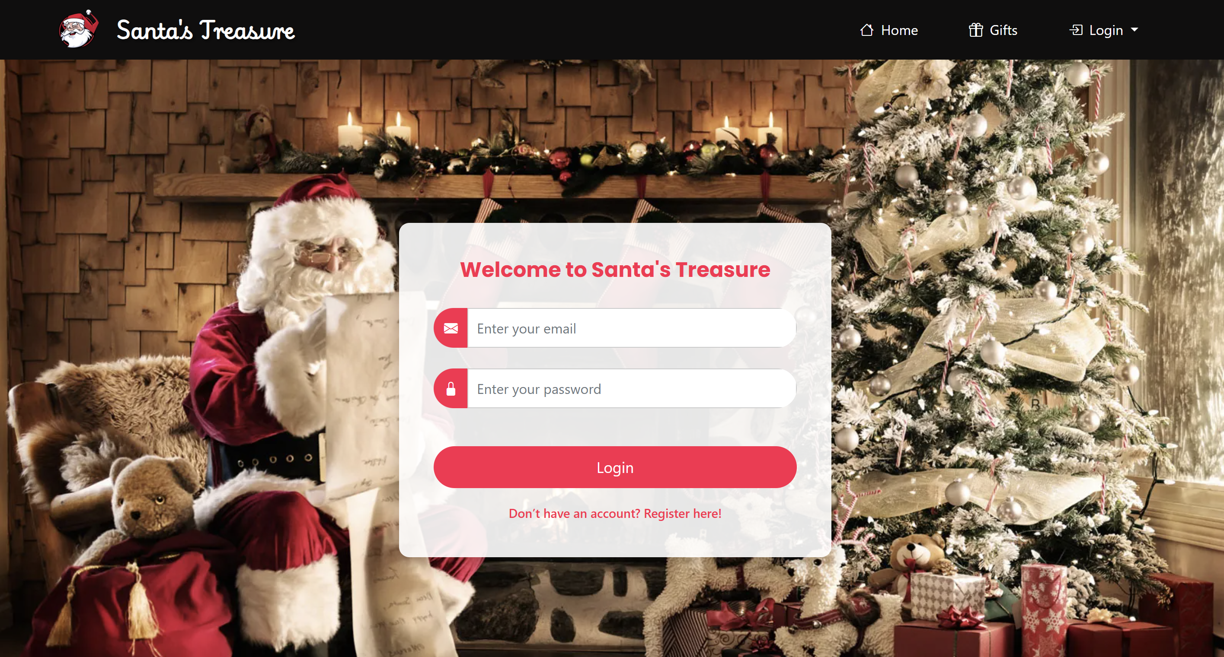

**Gifts Page for User**

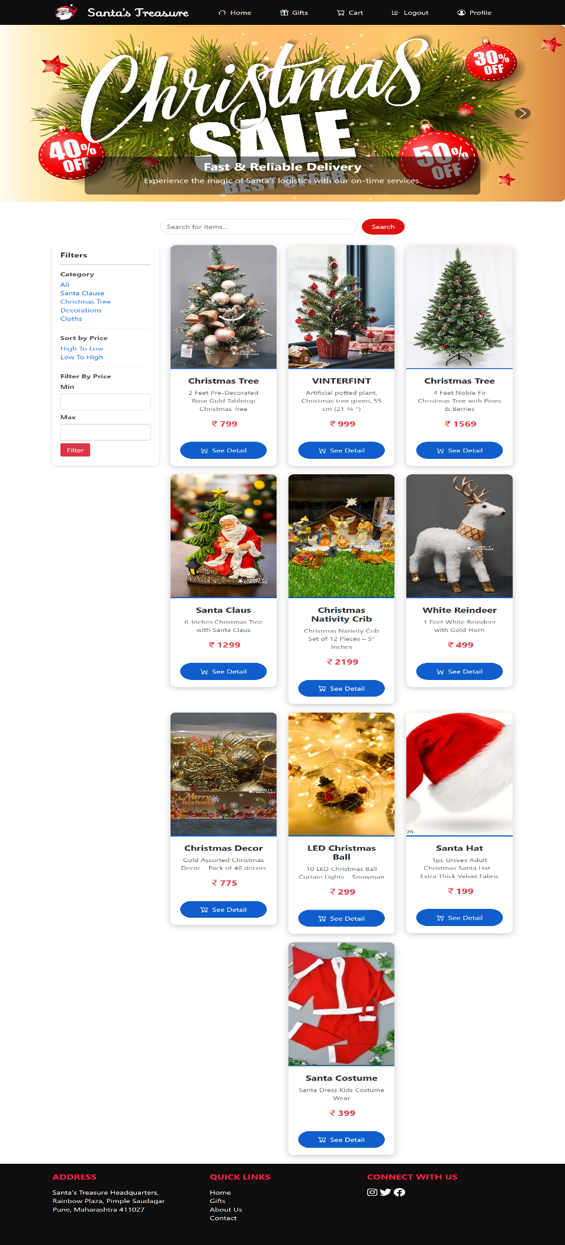

**Gifts Detail Page for User**

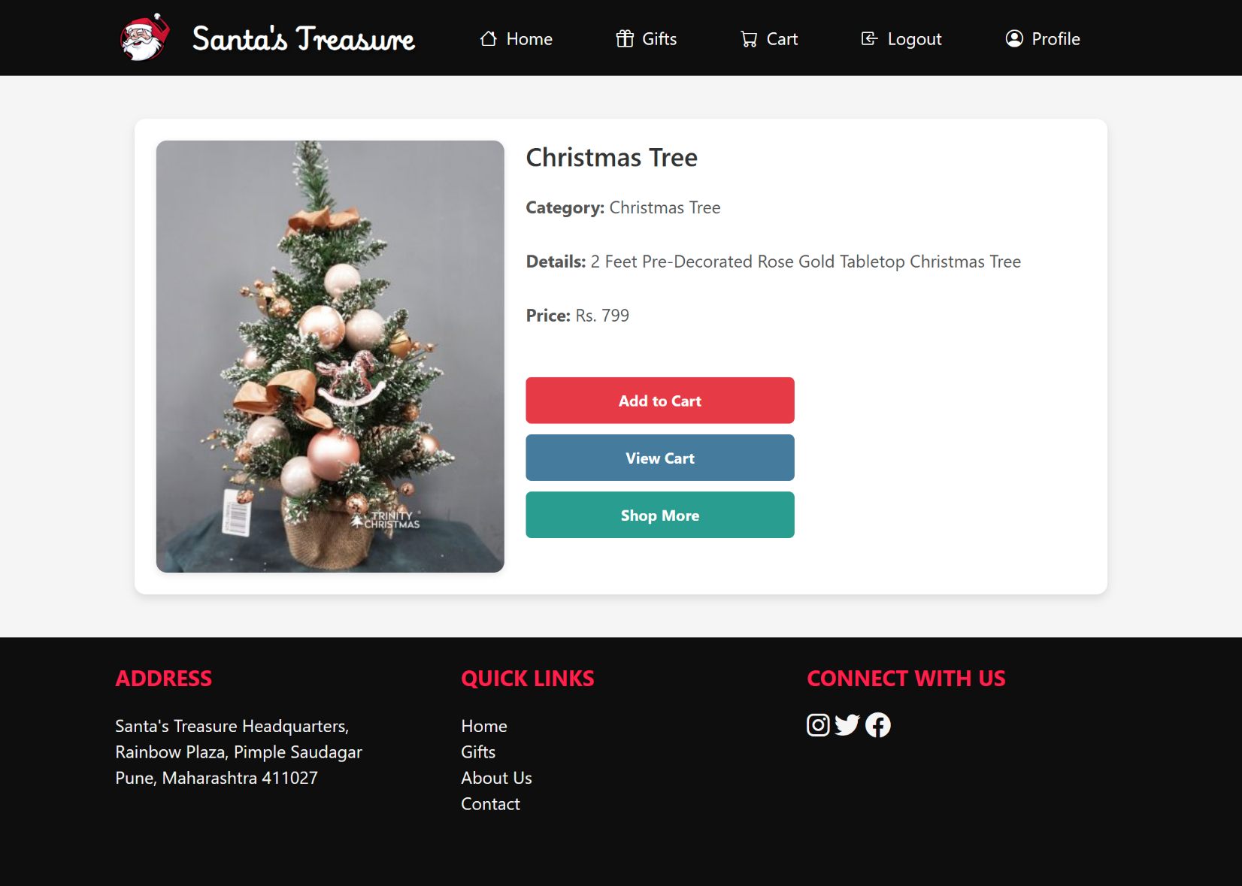

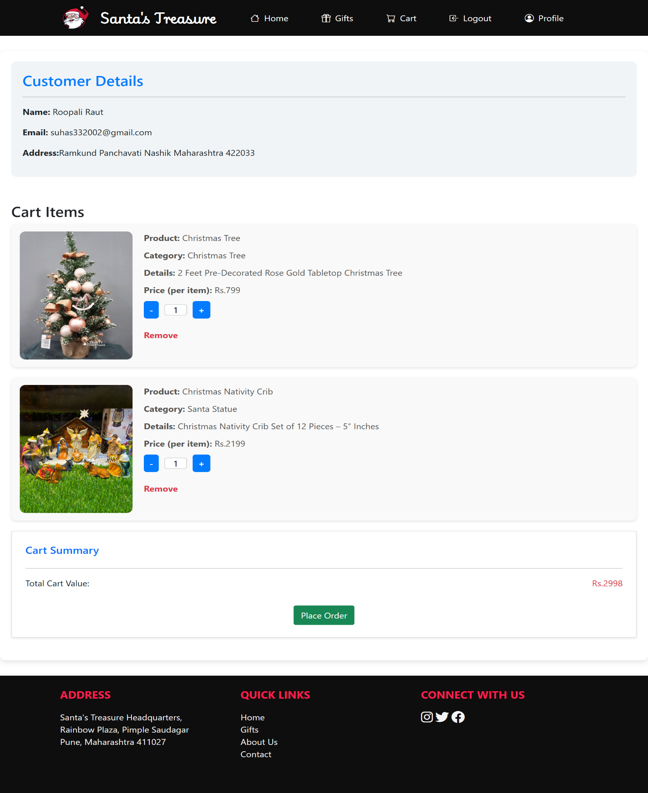**Cart Page for User**

**Place Order Page for User**

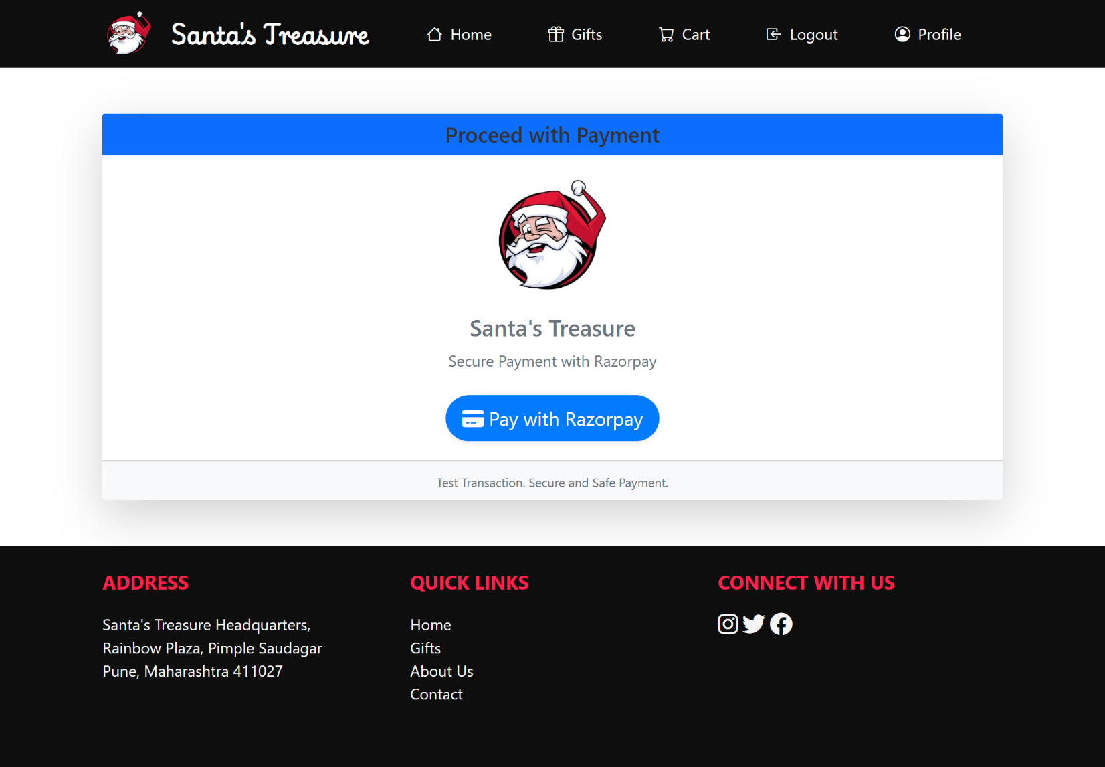

**Payment Page for User**

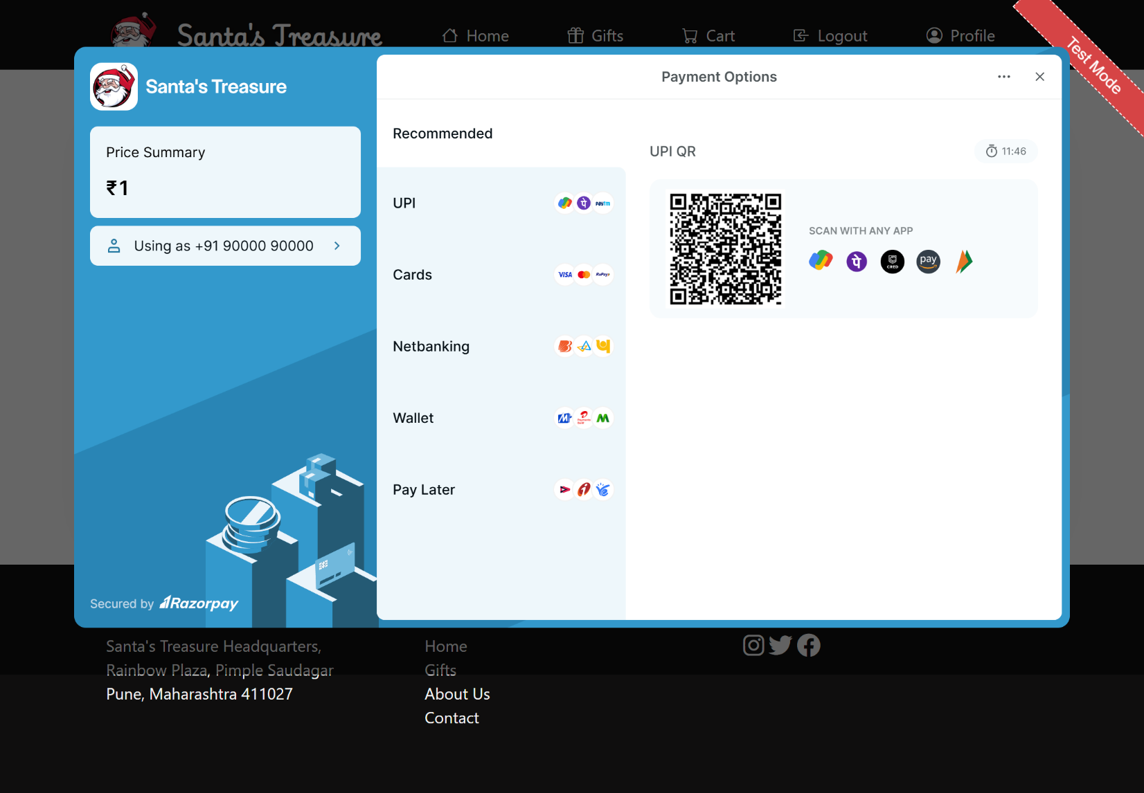

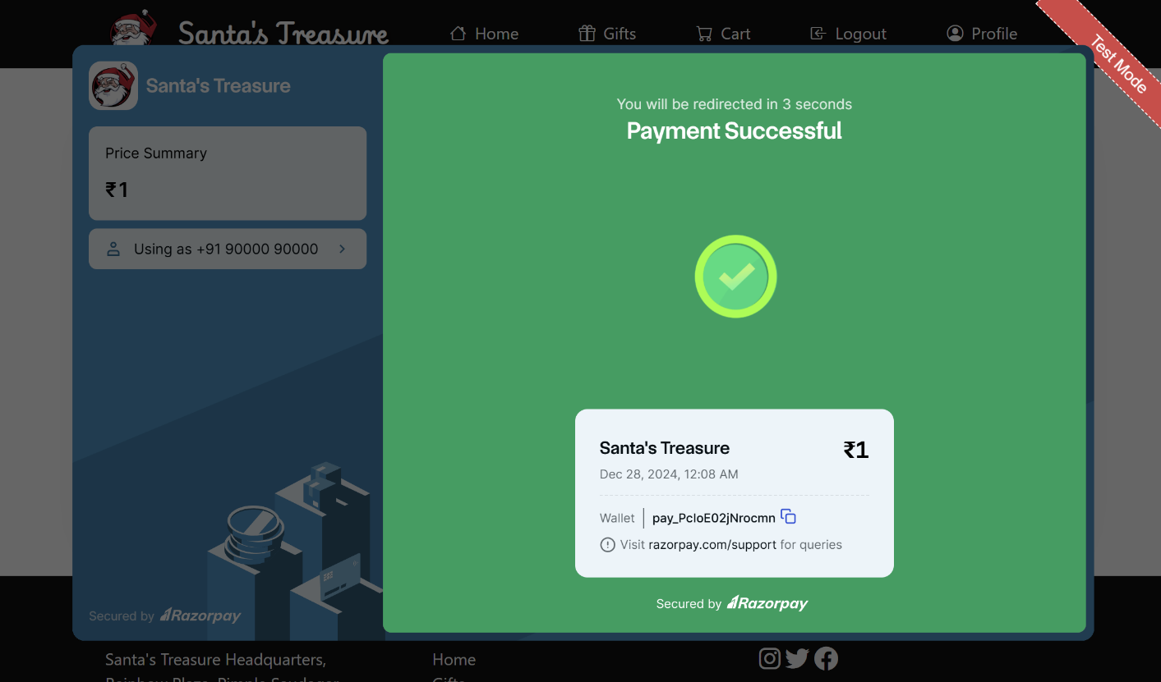**Payment Success Page for User**

**Order Placed Success Page for User**

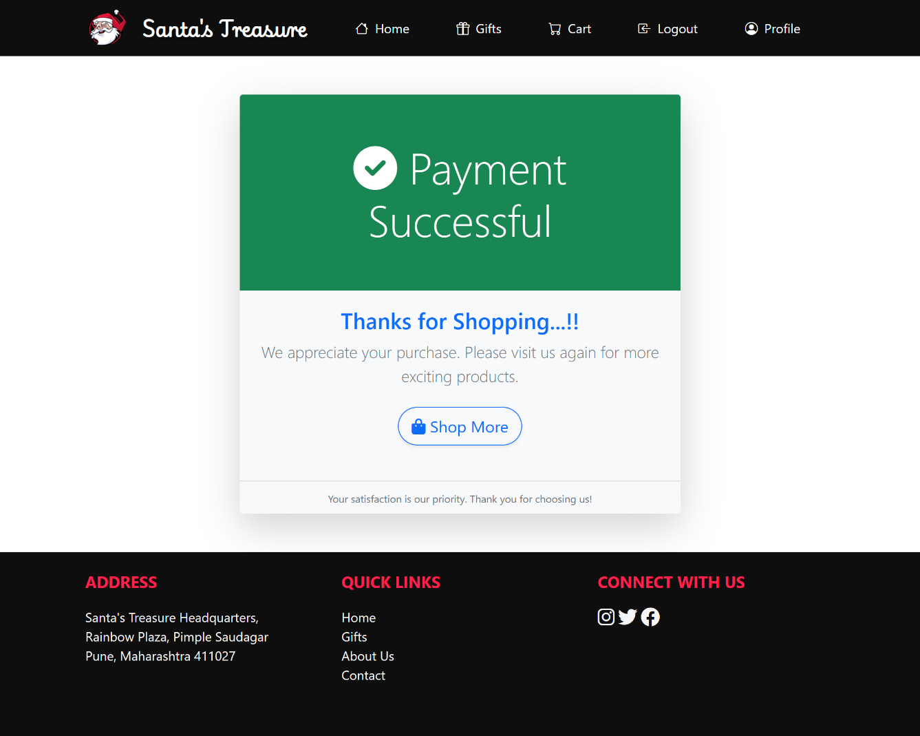

**Admin Dashboard :**

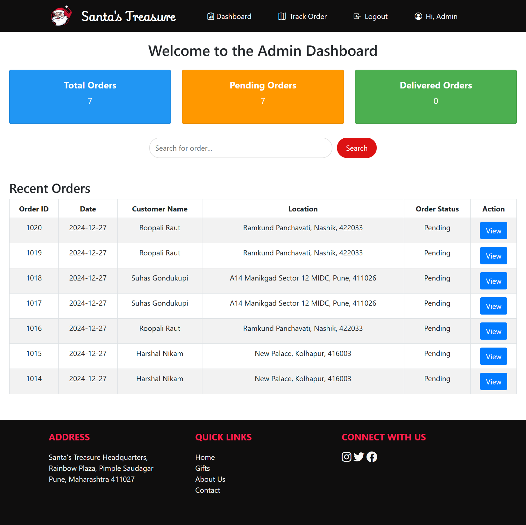

**Admin Filter based on Location :**

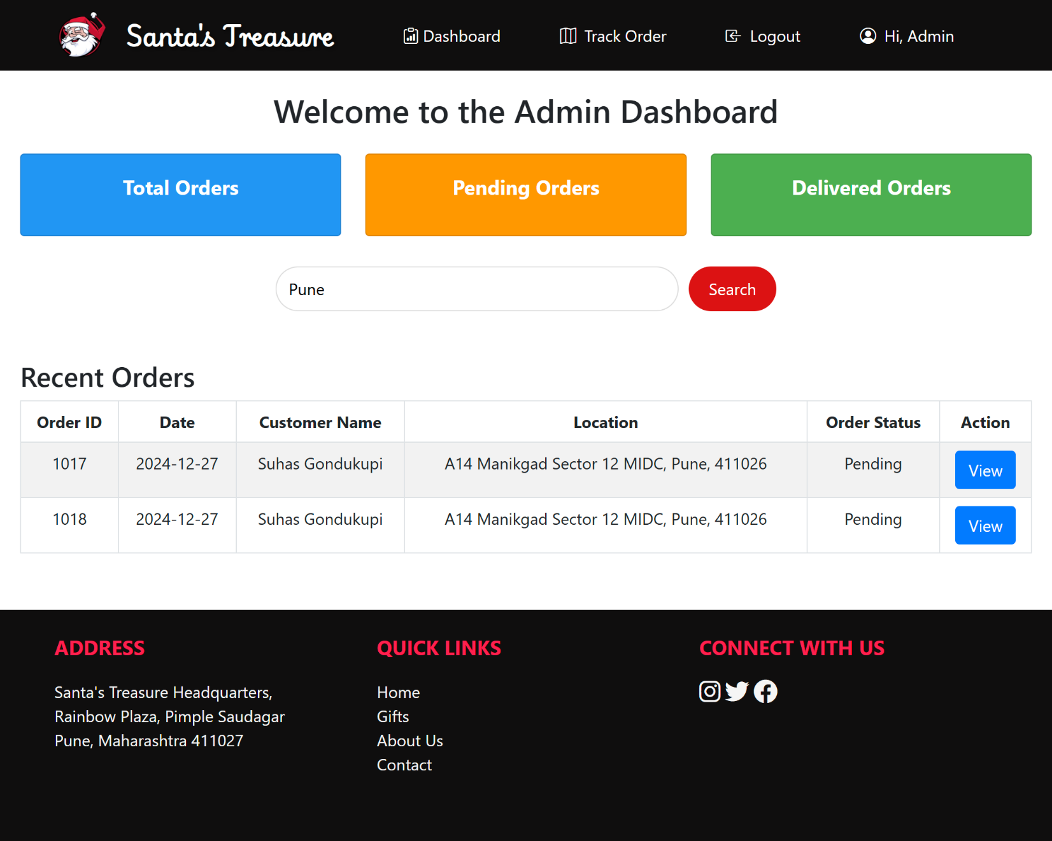

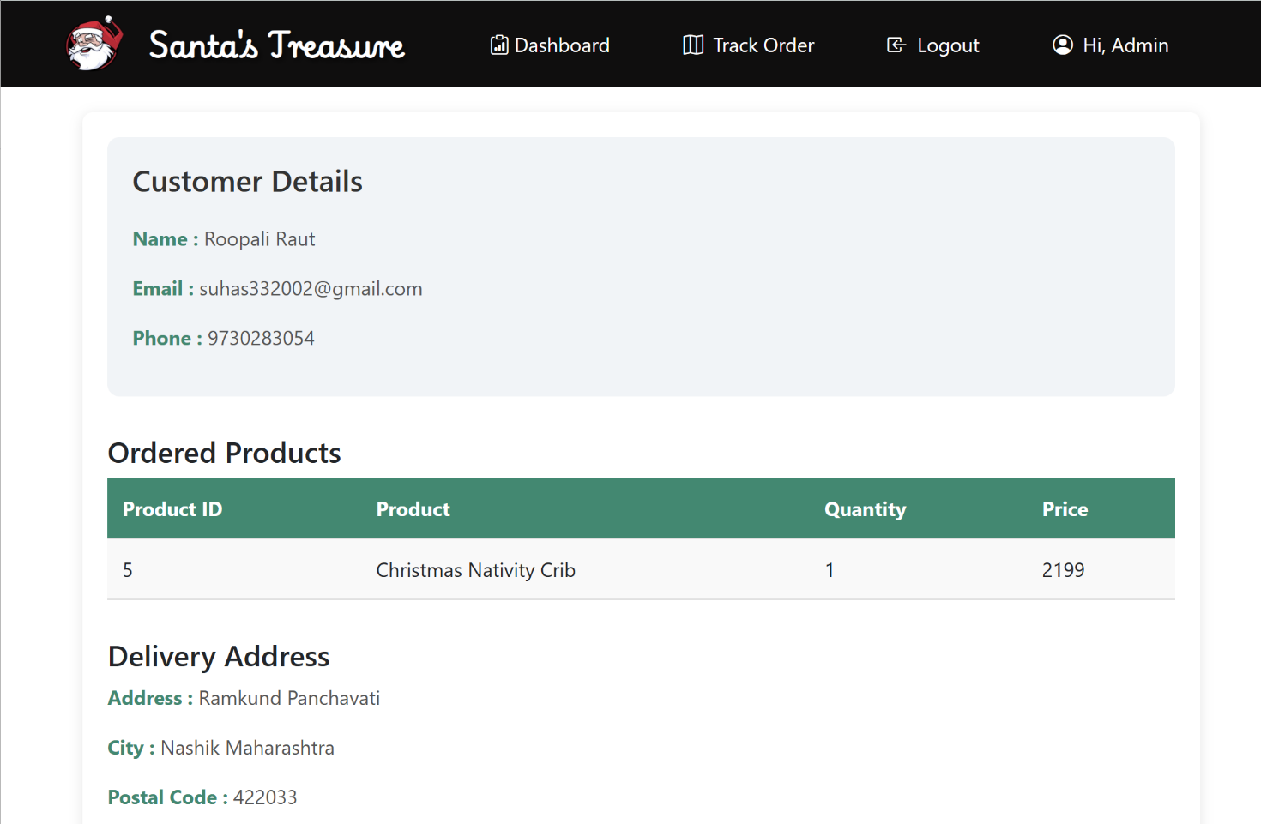**Admin View Action Page :**

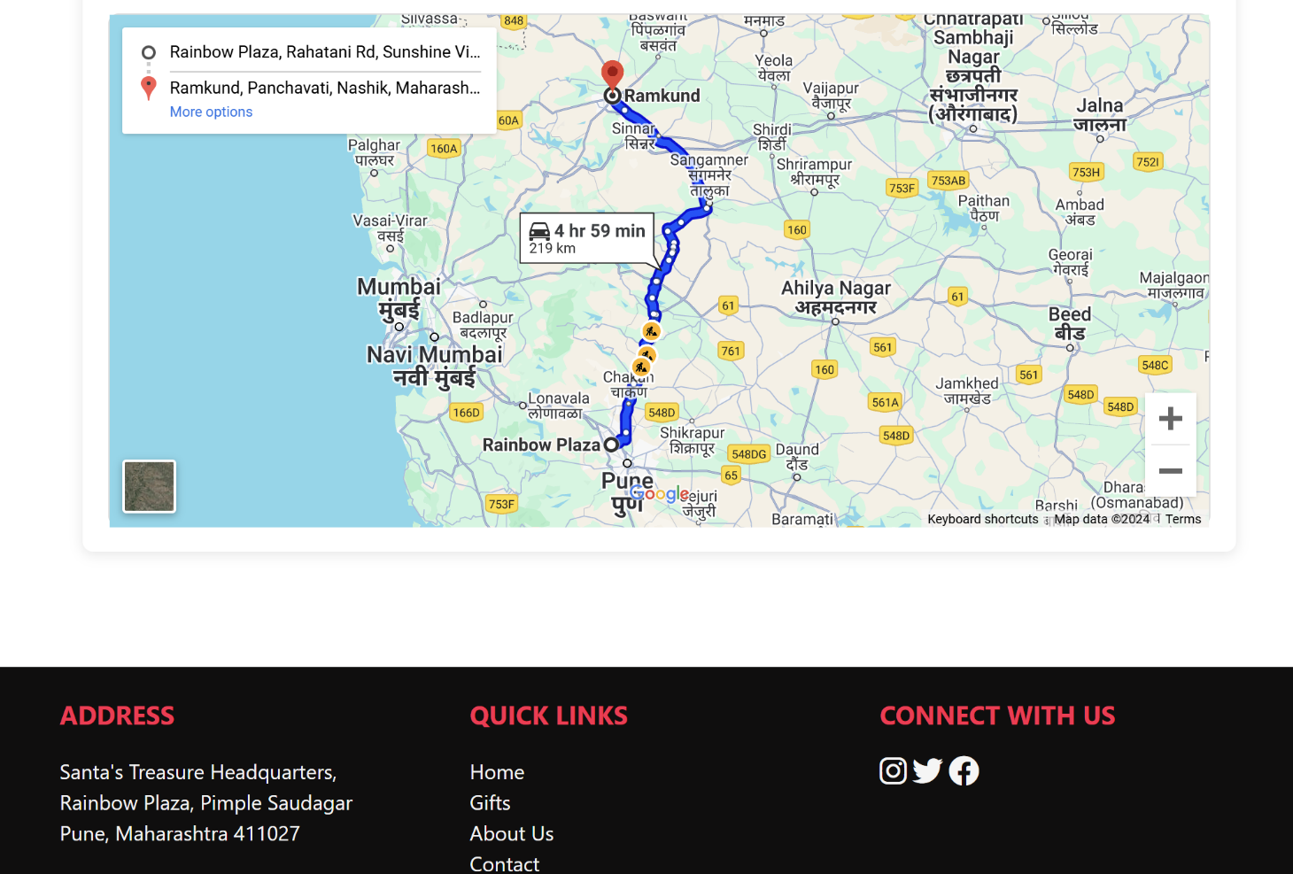

**Admin Track Order Page :**

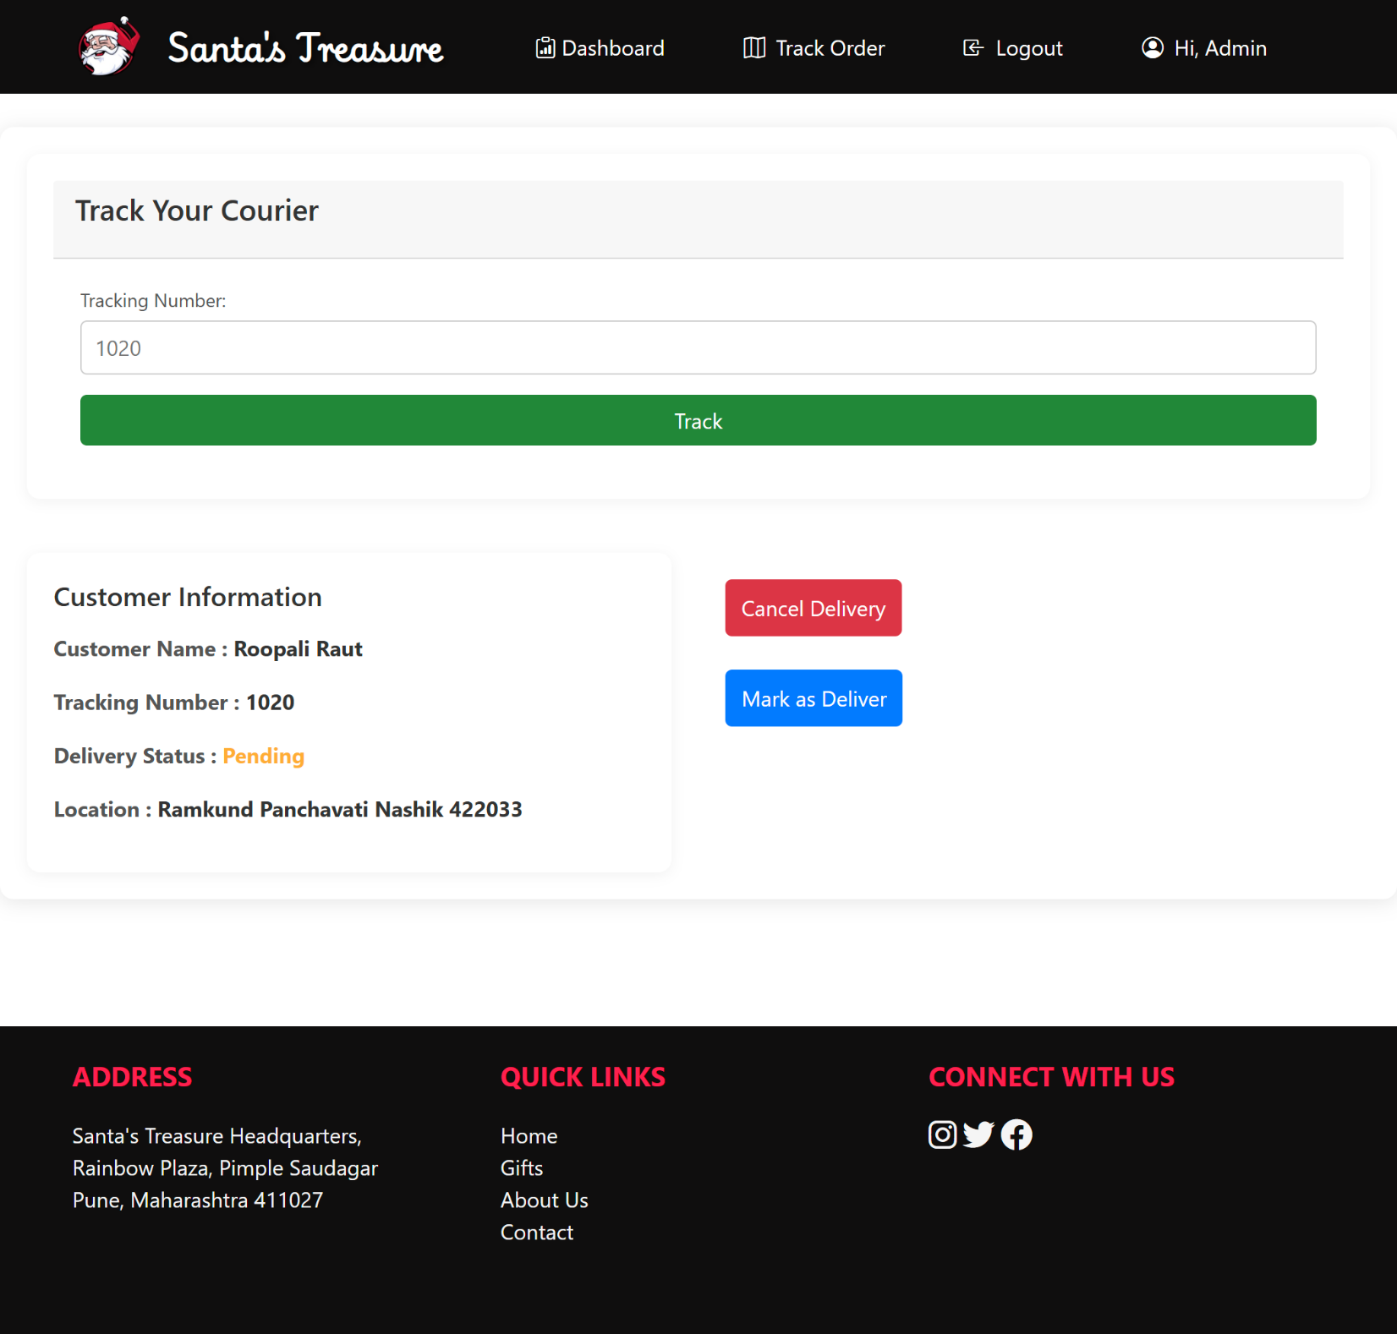

**Admin OTP Page for delivery :**

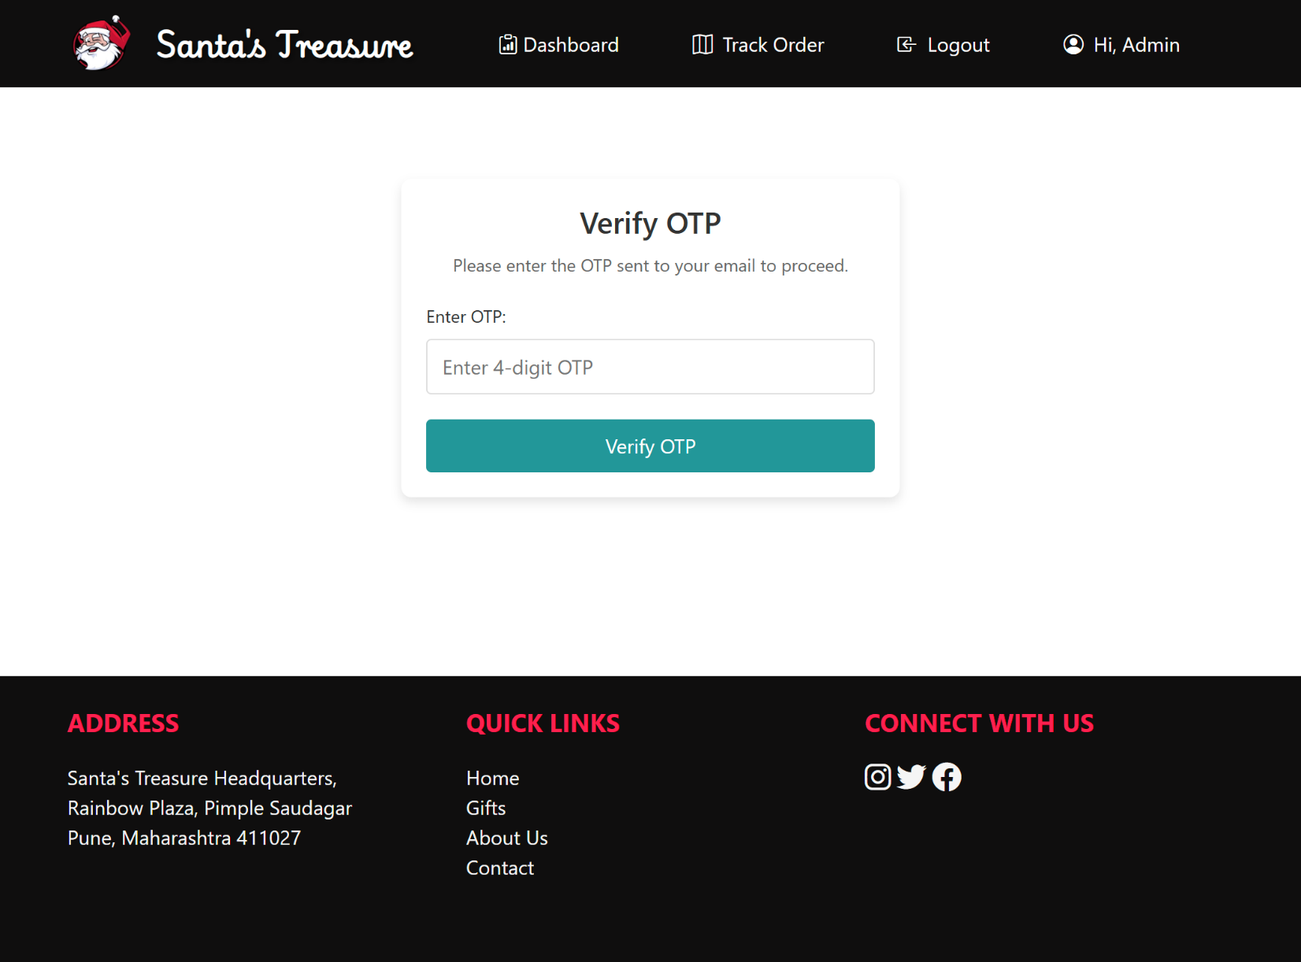

**Admin’s mail received to User**

